On December 18, 2019 at in St. Paul, the Builders Association of Minnesota held their Annual Meeting and 2019 Award Ceremony.

The BAM Champion of the Industry Awards were awarded to Senator Eric Pratt (R-Prior Lake) and to Representative Mike Sundin (D- Esko).

Senator Eric Pratt and Representative Mike Sundin were given this special award for stepping up, passing legislation and ensuring that legislative changes benefit and reflect priorities for the home builders in Minnesota.
"We thank Senator Pratt for giving us a chance to testify in his committee about our priorities; we thank him for legislation in his committee bill that funds a $1M consumer awareness campaign promoting licensure; we thank him for legislation that strengthens enforcement and support for licensed home builders, and for protecting the Contractor Recovery Fund."
-Remi Stone, BAM Executive Vice President
"We thank Representative Sundin for his work with us to pass legislation in the House of Representatives that also supports home builder licensure activities."
- Terry Hammack, BAM Past President

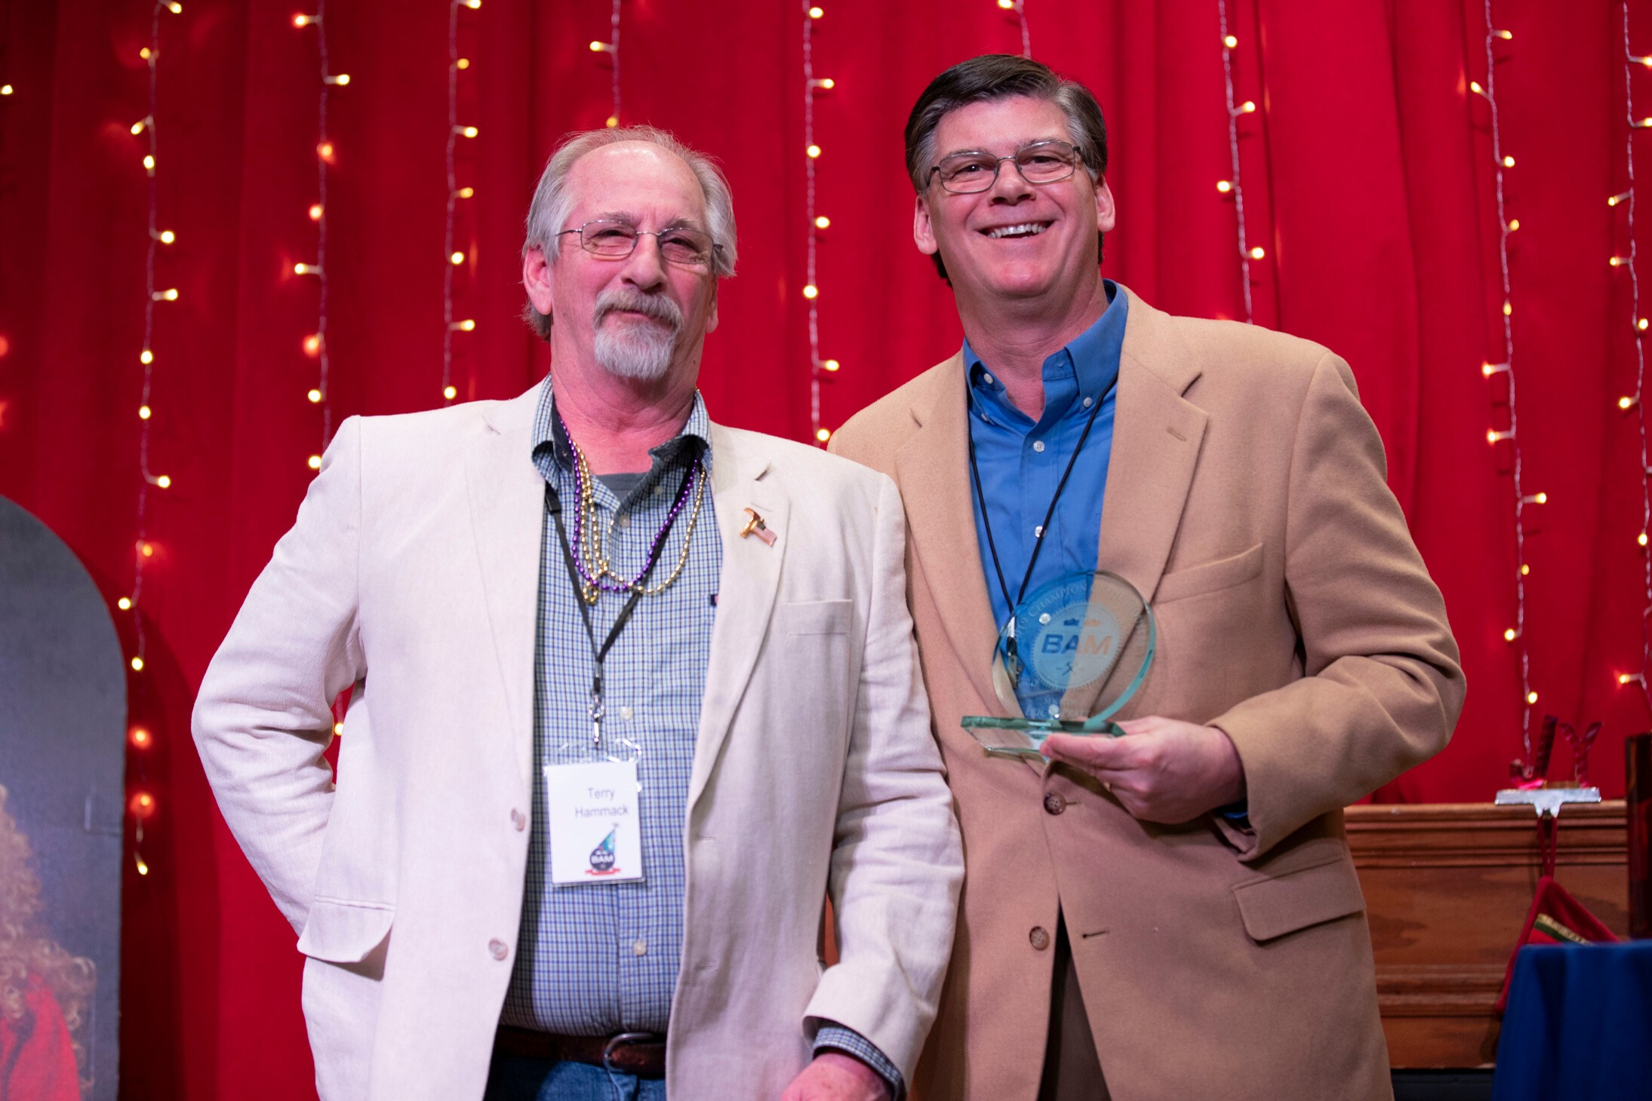

The BAM Team Impact Award goes to Dunwoody student, Tyler Fish.

The Team Impact Award is an award that has never been awarded. It represents a person who is willing to boldy step forward and support the efforts of BAM at the state Capitol. As an example of an indivuditul that represents the future of the industry, the Team Impact Award was given to Tyler Fish, a Dunwoody student.

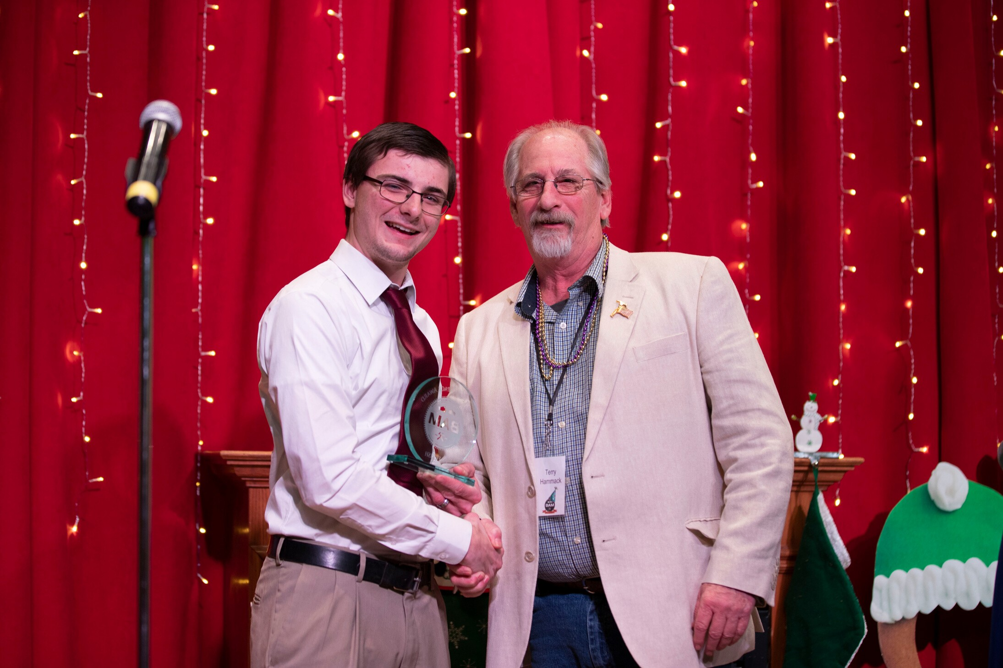

The BAM 2019 Associate of the Year Award was awarded to Pat Hegseth of Scherer Brothers, member of the Minnesota Metropolitan Contractors Association (MMCA).

The Associate of the Year award is presented to Builders
Association of Minnesota Associate members who, through working in the home-building industry, have gone above and beyond in their dedication to their
professions, their HBAs, and their communities. These exemplary members of the building industry are dedicated, operate with integrity, and encourage the
success of others around them. This prestigious award recognizes an individual who lives the values of the Builders Association of Minnesota, and works to make the building industry the most respected industry in the state.
The BAM 2019 Associate of the Year Award was awarded to Pat Hegseth of Scherer Brothers. Hegseth stepped in and took leadership in developing his affiliated local association, growing BAM and showing endless hospitality to all of our members.

The BAM 2019 Builder of the Year Award was awarded to Ben Edwards of Edwards/La Plant Construction, member of the Northern Minnesota Builders Association (NMBA).

The Builder of the Year award is presented to Builders Association of Minnesota (BAM) Builder members who go above and beyond in service of the homebuilding industry, the Builders Association of Minnesota, their local HBA, and their community. This distinguished award honors those who lead by example to encourage the advancement of the homebuilding profession and industry, and those who command the respect of their fellow members, colleagues, and communities through integrity and commitment to the values of the Builders Association of Minnesota.
The 2019 BAM Builder of the Year Award was awarded to Ben Edwards. Edwards stepped in and took leadership in helping find ways for BAM to grow, pressed BAM to improve its revenue streams, and elevated the importance of BAM's mission.

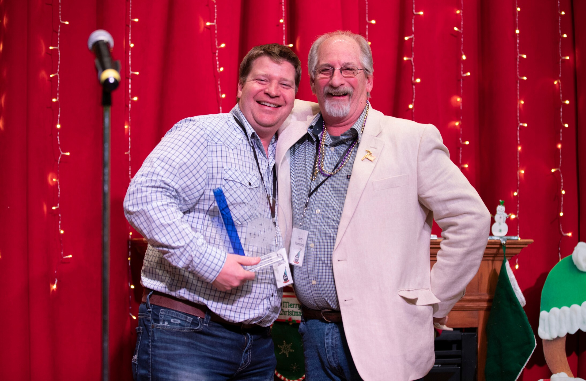

On December 18, 2019 in St. Paul, the Builders Association of Minnesota held their Annual Meeting and 2019 Award Ceremony.

2019 Champion of the Industry - Senator Pratt (R - Prior Lake)

2019 Champion of the Industry - Representative Sundin (D - Esko)

2019 BAM Team Impact Award - Tyler Fish

2019 BAM Associate of the Year
- Pat Hegseth

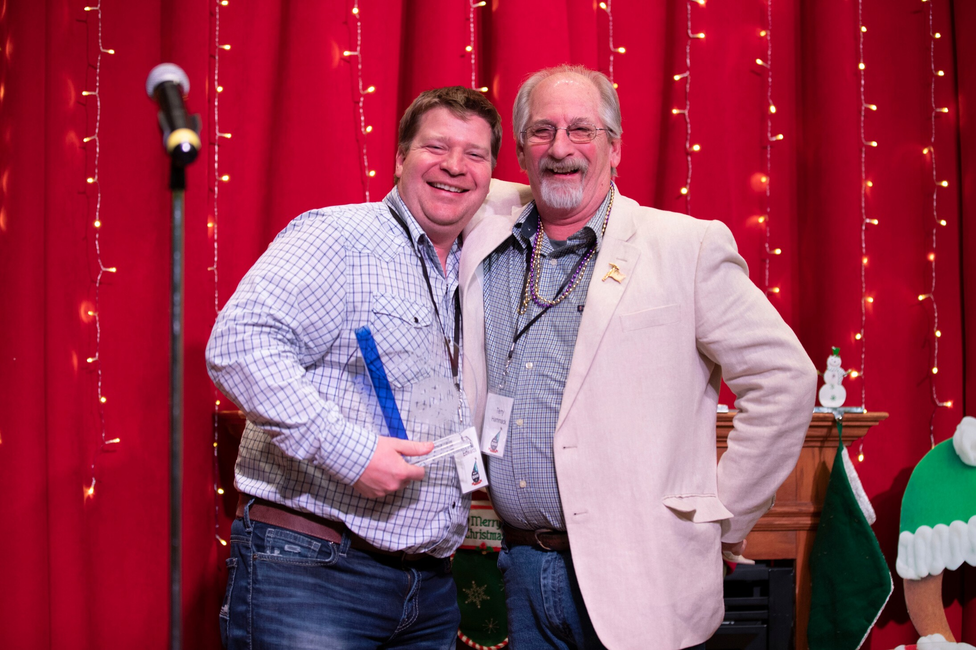
2019 BAM Builder of the Year - Ben Edwards

